THIS IS THE PROGRAM TO PRINT MY NAME(JITHENDRASAI.KILARU)

THIS IS THE CODE OF THE PROGRAM TO PRINT MY NAME:

org 100h

jmp start

msg: db "JITHENDRASAI.KILARU", 0Dh,0Ah, 24h

start: mov dx, msg

mov ah, 09h

int 21h

mov ah, 0

int 16h

ret

THIS IS THE PROGRAM OUTPUT TO PRINT MY NAME(JITHENDRASAI.KILARU)

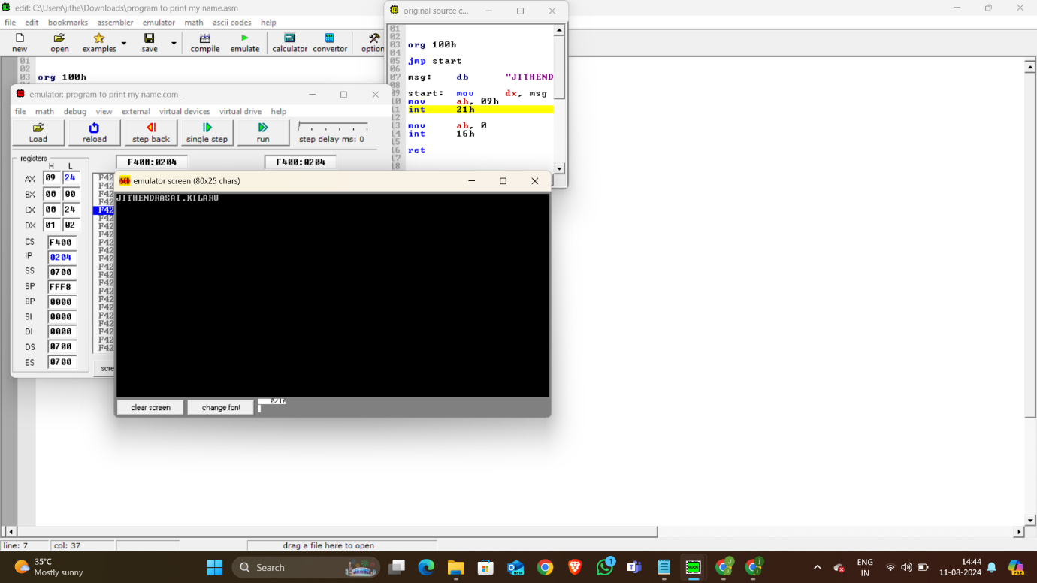

THIS THE PROGRAM TO PRINT Hello world!

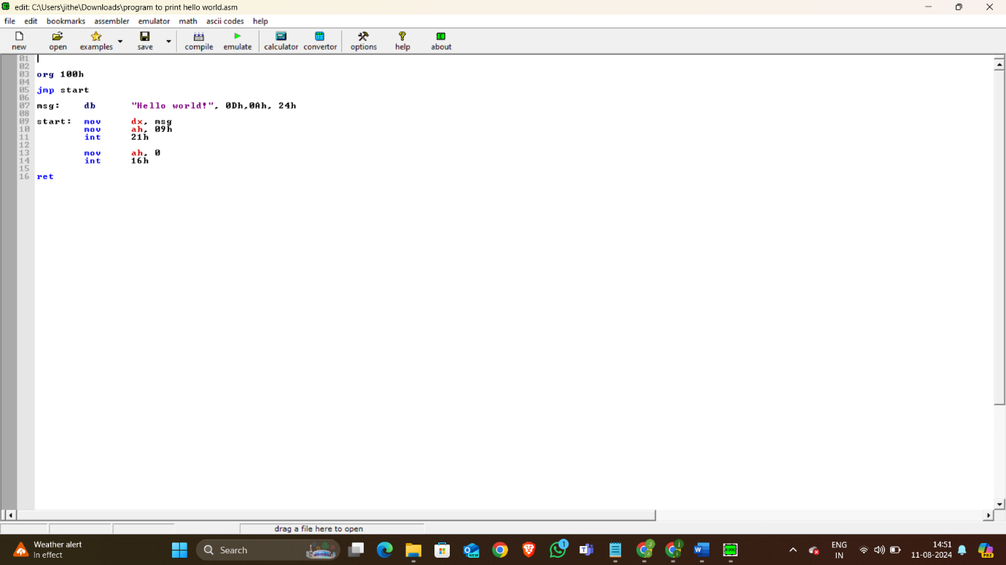

THIS IS THE PROGRAM OUTPUT TO PRINT HELLO WORLD!

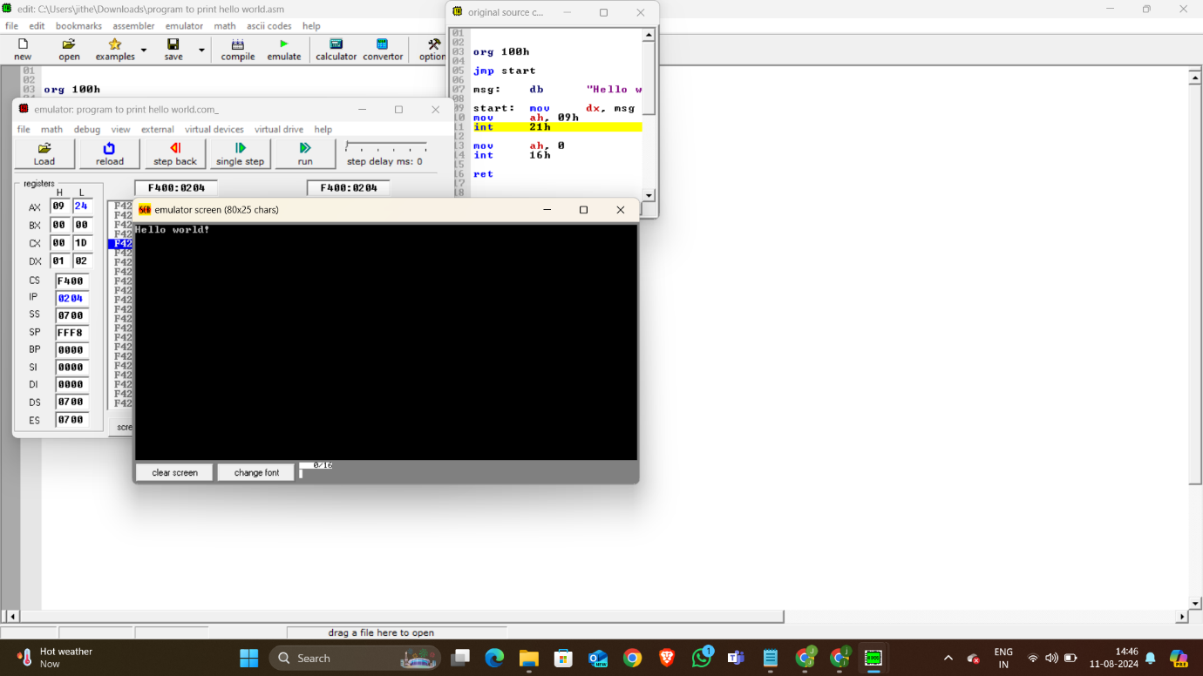

Code for the program to print Hello World:

org 100h

jmp start

msg: db "Hello world!", 0Dh,0Ah, 24h

start: mov dx, msg

mov ah, 09h

int 21h

mov ah, 0

int 16h

ret